FRIENDS OF MELBOURNE PARISH CHURCH NEWSLETTER, JANUARY 2025

Melbourne Rectory
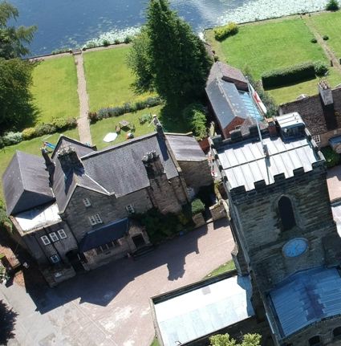
It was a relatively quiet year, business-wise, for The Friends, with the big and welcome exception the news that our campaign to keep the Rectory as part of our family of church buildings had been successful, for now at least. Contractors will be starting work on the Rectory refurbishment on January 6th with a completion date of 5th May 2025. During this time there will be boarding and scaffolding erected around the Rectory and normal access to the Honner room, Parish Office and the Rectory Garden may be temporarily affected from time to time. There will be no parking anywhere near the building. The Diocese has said it will review the situation in 5 years’ time and we will monitor events throughout that period.

The Rector of Melbourne Benefice

The advertisement for the new incumbent should be published in the very near future, hopefully shortly after you receive this newsletter. Two members of the Friends Executive Committee, who also sit on Melbourne PCC, were responsible for drawing up the profile of the benefice for the advertisement, including the descriptions of the four individual parishes which make up the Benefice (Melbourne, Smisby, Stanton-by-Bridge and Ticknall), so the need to cherish and protect the history and heritage of Melbourne Parish Church was well represented in the final draft.

Additions to our team

Our Executive Committee has four new members, or trustees as defined in our constitution. Glenn Crocker and Clive Avery are welcome additions to the team, while Judith Baron is a returning old friend as she was instrumental in setting up the charity at its outset and served as secretary for many years. It is good to have new blood and fresh ideas to restore some of the secular make-up of the committee. Alan Winfield, Associate Priest, will also be joining us as the clergy representative.

Membership

As reported at the last AGM our membership numbers are in fairly good shape. Individual and family member numbers are more or less the same as last year at around 220, which is very encouraging, but we have lost a couple of business members and a valued corporate member in the form of The Bay Tree, as it has now closed. This business, at the centre of Melbourne social life for many years, has been a very loyal and supportive member and we wish Rex a happy retirement and the rest of the team well in their new adventures.

Finance

It was reported at the AGM last October that our balance at the bank was £24,576.18. The purpose of The Friends is, of course, to spend money in support of worthwhile projects rather than simply accumulate funds. We are aware that the church will be facing some large outlays in the foreseeable future for, amongst other things, urgently needed upgrades of its electrical and heating systems and we are currently saving in order to be able to contribute appropriately to such projects when the time comes.
﻿﻿﻿

Events in 2024
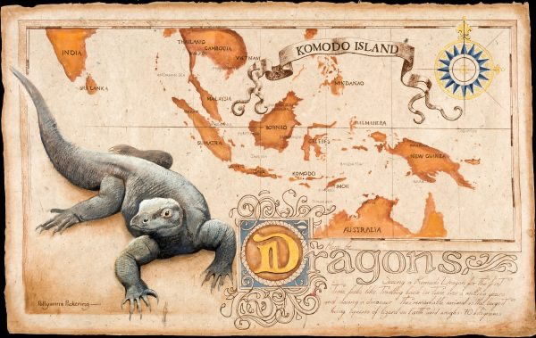
Despite having to cancel two of our events last year, we still managed to deliver a good mixture of music and talks. In June, we heard about the Vanishing Lady of Tutbury, a strange and intriguing tale told by local historian William Bates. In August, Anna-Louise Pickering, writer, photographer and conservationist spoke about her trip to Indonesia and Borneo with her wildlife artist mother Pollyanna, where they encountered the fearsome Komodo Dragon.

In September, as part of the Melbourne Festival Fringe, Graham Oppenheimer and Friends played some wonderful pieces of chamber music from across Europe and in October the Ben Crosland Quintet gave us ‘Solway Stories’, displaying their great mastery of a mix of jazz styles.
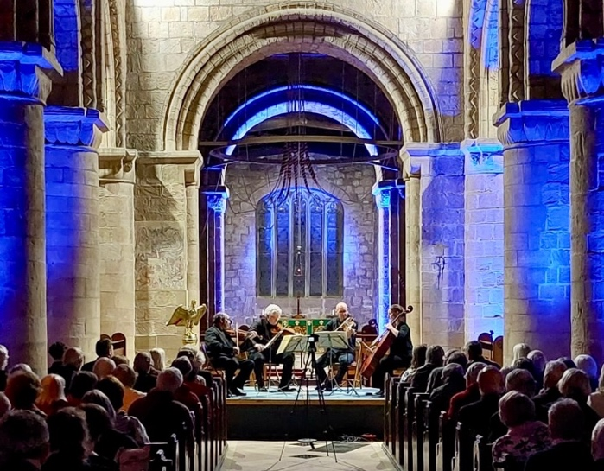
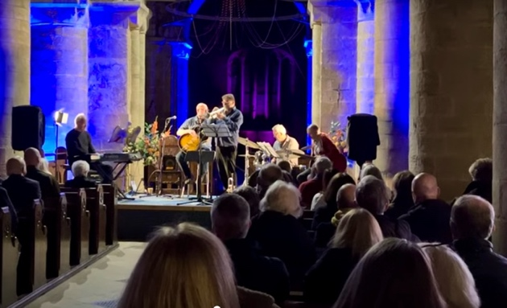
We are very grateful for the sponsorship kindly provided by East Midlands Airport and Alan Staley Building Contractors Limited without whom we would not be able to put on events of this quality. Alan Staley is a longstanding corporate member of the Friends, who has done, and continues to do, so much to maintain and improve our church buildings.

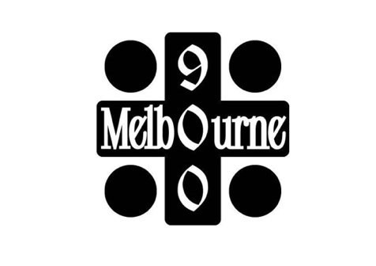
Events planned for 2025

Melbourne Parish Church celebrates its 900th anniversary this year. While no one knows the exact year the current church was founded, 2025 is certainly not far from the mark and has a nice ring to it.

A committee, reporting to the PCC, has been set up to organise a series of events to mark the anniversary, so this year The Friends are working with that committee to coordinate the activities and avoid duplication. There is a lot happening. The committee approached The Friends for a grant to fund some of the events and we agreed to provide £2,000 in support of activities which clearly meet our charitable aims of connecting the church with the wider community and raising its profile.

The events planned so far are listed below, with those solely organised by the Friends indicated by an asterisk.

- January 12th – Service of Thanksgiving for Nine Centuries
- February – Erection of a timeline around the east end of the church, showing national and local events over the last 900 years
- April 3rd – Talk by Philip Heath, 7.30pm: “The chequered history of Melbourne Parish Church over 900 years”
- May 3rd to 5th – Flower Festival celebrating 900 years
- May 15th or 22nd – A Whodunnit evening presented by Margaret Gildea: Who murdered the Princes in the Tower?*
- 5th or 9th June – Talk by William Bates on the contentious restoration of Melbourne Parish Church in the 1860s*
- June 14th – Medieval Fayre and Hog Roast
- July 4th – Evening Medieval Banquet
- July 19th - An architectural and historical tour of the church and surroundings by Philip Heath, 2pm
- August 16th - An architectural and historical tour of the church and surroundings with Philip Heath, 2pm
- A Choir’d Taste – morning coffee concert
- September 20/21st – Melbourne Festival
- September 25th – Chamber music from Graham Oppenheimer and Friends*
- September 28th – Patronal Festival
- October 2nd – Talk by Philip Heath, 7.30pm: “The chequered history of Melbourne Parish Church over 900 years”
- October 16/17th - St Michael’s Players drama group – a humorous look at Melbourne over the last 900 years
- December 5th – Jazz night: A Christmas Carol with Alan Barnes*
- December 13/14th – Christmas Tree Festival

Dates not yet fixed:

- Michael Cook and other artists – an exhibition named “Wild Saints”
- Joint Performance by the various music groups in Melbourne
- Talk by William Kerr on the church’s early history
- Talk by Rachel Askew about the years leading up to 1125 and the religious milieu in which the Church was conceived – probably early September
- Fun quiz in and about Melbourne Parish Church

The Nine Hundred

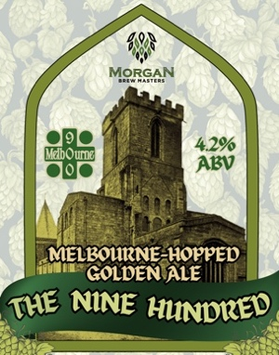
The Spirit Vaults, just opposite the church on the other side of Church Street, brewed a special ale to mark the 900 anniversary – a smooth, golden brew made using local hops. The first batch sold out within days and another brew is currently settling and will be on sale towards the end of January. It will be available in bottles from Melbourne Parish Church (contact the Parish office on melbourneparishchurch@gmail.com) and from The Spirit Vaults itself in bottles and in draft. A proportion of all sales is going towards funding the 900-year celebrations.

Our Business and Corporate Members

Corporate Members

Adrian Wagstaff Financial Planning
Alan Staley Building Contractors Ltd.
Crane & Walton LLP Solicitors
J P Springthorpe & Co.
TUK Rural

Business Members

Birds Confectioners
Caslon Press
Doves Garage Ltd
East Midlands Airport
Forteys Sweet and Coffee Shop
Lemon and Lime Interiors
Melbourne Florist
Melbourne Gun
Melbourne Hall Tea Rooms
Melbourne Medical Writing Ltd.

Melbourne Town Band
Millpond Antiques & Collectibles
P & J Transport
Pierre Hourlier Wines
Quill International Group
Royal British Legion (Melbourne Branch)
Staunton Harold Estate
The Spirit Vaults
W R Spiers – Family Butcher
White Swan Inn
Zeerah Restaurant

